Experiment 7
Write a program to implement Logistic Regression (LR) algorithm in python

Aim
To implement the Logistic Regression (LR) algorithm in Python to classify data and evaluate the model performance.

Program
# Logistic Regression with Confusion Matrix and Accuracy
import pandas as pd
from sklearn.linear_model import LogisticRegression
from sklearn.metrics import confusion_matrix, accuracy_score
# Dataset given directly
data = {
'Age': [22,25,47,52,46,56,48,55],
'Salary': [15000,20000,50000,60000,52000,65000,62000,70000],
'Buy': [0,0,1,1,1,1,1,1]
}
df = pd.DataFrame(data)
# Features and target
X = df[['Age','Salary']]
y = df['Buy']
# Create model
model = LogisticRegression()
# Train model
model.fit(X, y)
# Predict
y_pred = model.predict(X)
# Confusion Matrix
cm = confusion_matrix(y, y_pred)
print("Confusion Matrix:\n", cm)
# Accuracy
acc = accuracy_score(y, y_pred)
print("Accuracy:", acc)

Output

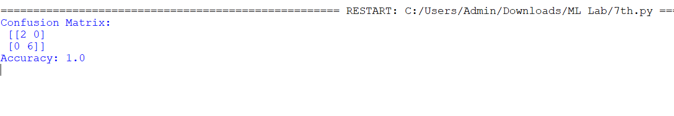

Result
The Logistic Regression algorithm was successfully implemented in Python and the model performance was evaluated using confusion matrix and accuracy score.

